Fitting Instructions:

1. Open Twizy door and using a Torx tool unscrew the 3 bolts at top of inner door lining 5 turns (but do not remove the bolts).

2. Insert window (soft rubber trim facing you) so the 3 slots slide under the 3 bolt heads as far as the window will go (see below). Holding the window re-tighten all 3 bolts (do not overtighten as it may crack window).
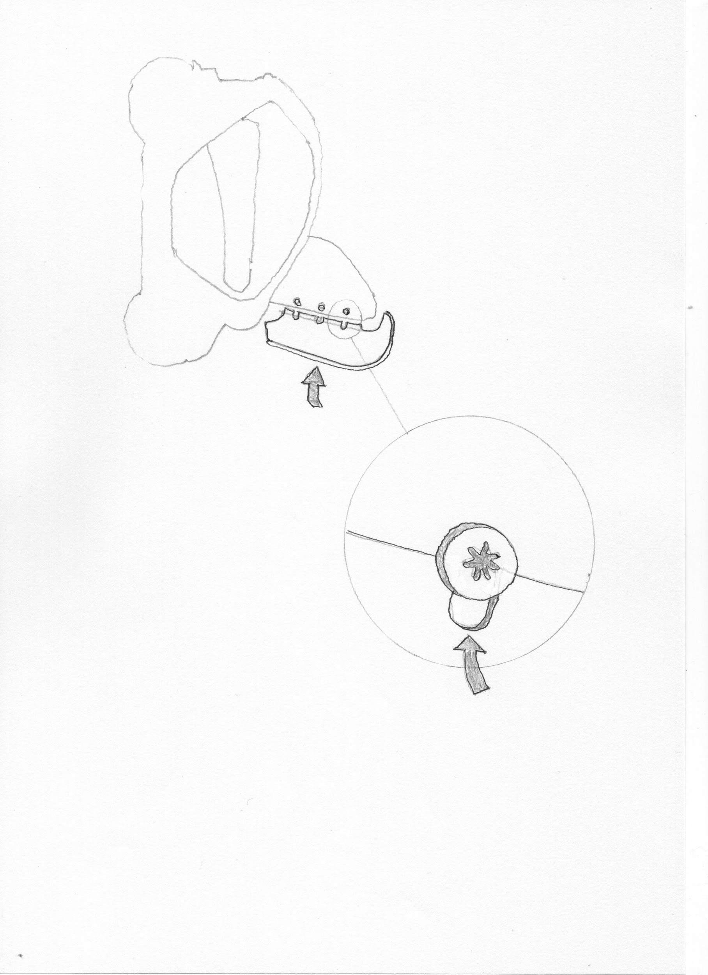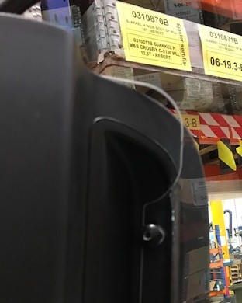
3. Close door and sit in Twizy. Before fixing the magnetic mount & metal plate find the best position. The best position is near the top corner of the window. The rubber trim should lie on the Twizy frame for best seal (see below). Remove the rubber cap from the magnet for best strength. Once you have the best position mark with a pencil or sticky tape. Clean and dry surfaces with alcohol wipe (included) before final fitting. The plastic base plate can be bent or cut with scissors for the closest fit.

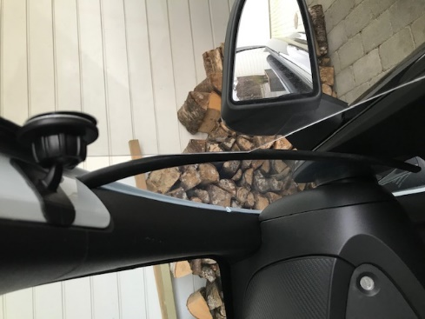

IMPORTANT: Apply firm pressure to the base and metal plate for at least 2 minutes. Check after driving that the position is correct and apply glue when you are happy.

When opening doors use one hand to gently flex window away from the frame as the door swings open. This prevents the window from being scratched.

Caution: Never leave doors with windows open in strong winds. Excessive flexing may damage them.
For latest updates see website at www.twizywindows.co.uk Thank you for your purchase and happy Twizying!

